Download vdi image:

<https://www.osboxes.org/linux-mint/#linux-mint-22-1-vbox>

direct link:

<https://sourceforge.net/projects/osboxes/files/v/vb/31-Lx-M-t/22.1/Cinnamon/64bit.7z/download>

* Extract it (install 7Zip to extract)



Open Orcale Virtualbox:

* Click new
* Then type Name as Linuxmint
* Then Finish

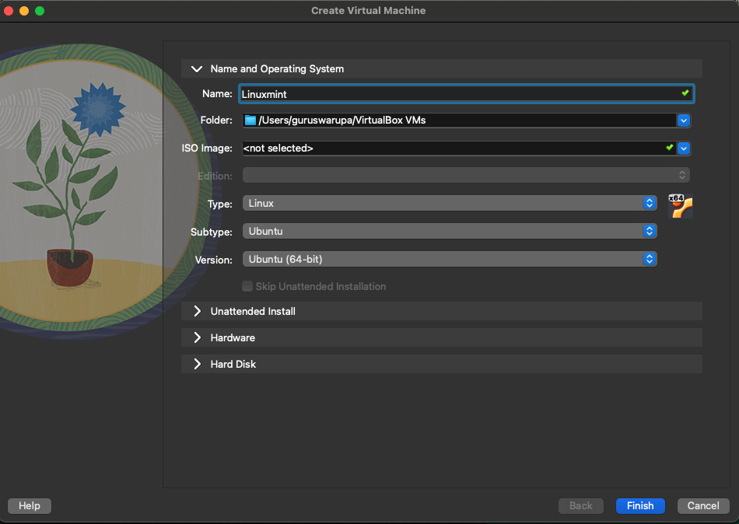

* Open settings of the created
* In System > Motherboard change the Base Memory to atleast 4096 Mb or higher for good User Experience
* In System > Processor change processor count for better Performance
* In Storage > Controller: SATA > Add Harddisk > add the extracted vdi image and choose that vdi image
* Press ok
* Boot the vm

If Internet doesn’t work,

* Open settings > network > Change from NAT to Bridged Adapter and save and try